STROUD DISTRICT COUNCIL

Council

Thursday, 20 July 2023

Report Title | Community Governance Review – Final recommendations
Purpose of Report | To make final recommendations to parish arrangements in the district in relation to the Community Governance Review.
Decision(s) | Council RESOLVES to:  - approve the final recommendations in relation to the Parish/Town Council areas within the Stroud District as set out in this report;  - authorise the Corporate Policy and Governance Manager to:  - request that the Local Government Boundary Commission for England make alteration orders to change district wards to reflect the changes made to parish boundaries; and  - make a reorganisation of community governance order to implement the changes approved by Council, subject to receiving the necessary consents from the Local Government Boundary Commission for England.
Consultation and  Feedback | The Community governance review process was undertaken in accordance with the published guidance and agreed terms of reference. It included two periods of public consultation with stakeholders and other interested parties. Links to the responses received during the consultation period can be found in the Appendices listed below. A Member/Officer Working Group was established to consider all of the consultation responses and produce the draft and final recommendations based on statutory criteria and the responses received.
Report Author | Jenna Malpass, Senior Democratic Services and Elections Officer  Email: jenna.malpass@stroud.gov.uk  Hannah Emery, Corporate Policy and Governance Manager  Email: hannah.emery@stroud.gov.uk
Options | There is no statutory duty placed on the council to undertake community governance reviews, it therefore has the option to cease work at any time. However, given the stage now reached there is a legitimate expectation the review will be taken to its natural conclusion. Therefore, there are no feasible alternative options. The Working Group considered all options when reviewing the consultation responses and were mindful to make appropriate amendments following responses received to consultation on the draft recommendations. All recommendations have also been evaluated against the statutory criteria.

Background Papers | - Community Governance Review for Stroud District - Report to Council 20 October 2022  - Terms of Reference  - Stroud District Council Community Governance Review – Draft Recommendations  - Guidance on Community Governance Reviews – Communities and Local Government and The Local Government Boundary Commission
Appendices | Appendix A - Final Recommendation Maps  Appendix B - First Stage Consultation Responses  Appendix C - Second Stage Consultation Responses  Appendix D - Equality Impact Analysis
Implications  (further details at the end of the report) | Financial | Legal | Equality | Environmental
Implications  (further details at the end of the report) | No | Yes | Yes | No

INTRODUCTION / BACKGROUND
  - The Council at its meeting on the 20 October 2022 resolved to undertake a Community Governance Review (CGR) for the parishes of Cam, Dursley, Eastington, Frampton, Horsley, Hunts Grove, Minchinhampton, Nailsworth, Standish, Stonehouse and Woodchester. Council agreed the Terms of Reference for the review which included establishing a Member/Officer Working Group to review the consultation responses and produce the draft and final recommendations.
  - The process for carrying out a Review is set out in the Local Government and Public Involvement in Health Act 2007 and associated guidance. Appropriate consultation has been carried out, the views of electors and others in the area have been sought and this report represents the final element of the CGR that the Council commenced in 2022.
  - If the Council agrees the recommendations, any changes made as a result of the review would take effect for the next elections in 2024. Work will commence immediately to make the necessary Reorganisation Order to bring the changes into effect in time for the May 2024 district and parish council elections. Members will note that, for some of the proposals, the final position is dependent on the agreement of the Local Government Boundary Commission for England.
  - After the first consultation period closed, a Member/Officer Working Group was established to oversee the review and consider the responses received. The Working Group has conducted a very thorough and extensive review of parish governance arrangements in the areas set out in the report. It has prepared recommendations it considers align to the statutory criteria to better reflect the identity and interests of local communities and provide more effective and convenient local governance.
  - The Councillors who attended Working Group meetings were Councillors Aldam, Cornell, Stephen Davies, Evans, John Jones, Hurst, Patrick, Ross (Chair), Ryder and Turner.
  - A brief summary of the recommended changes is included in the table below, detailed information regarding the recommendations can be found in sections 6 to 13.
Area | Final Recommendations
Cam | - A Community Governance Review for Cam parish is held before 2028
Dursley | - No changes
Eastington | - A new parish of Great Oldbury will be created with SEVEN parish councillors  - Changes are made to boundaries of the existing parishes of Eastington, Standish and Stonehouse to accommodate the Great Oldbury Parish  - The number of Parish Councillors for Eastington is decreased to NINE
Frampton | - The number of Parish Councillors for Frampton-on-Severn Parish Council is increased to TEN  - A Community Governance Review for Frampton-on-Severn Parish is considered in the future if the development at Oatfield becomes established
Horsley | - No changes
Hunts Grove | - The number of Parish Councillors for Hunts Grove is increased to NINE
Minchinhampton | - A Community Governance Review for Minchinhampton Parish and Brimscombe and Thrupp Parish is held before 2028
Nailsworth | - No changes
Standish  (See Eastington for Great Oldbury Recommendations) | - No changes are made to the councillor allocations for Standish Parish Council  - A Community Governance Review for Standish Parish is considered in the future the development at site PS19a becomes established
Stonehouse  (See Eastington for Great Oldbury Recommendations) | - No changes are made to the councillor allocations for Stonehouse Town Council  - The warding arrangements of the Town of Stonehouse are redrawn to create three wards, North, Central and South Wards and the allocation of Councillors is redistributed across the wards
Woodchester | - No changes

BACKGROUND TO THE 2022/23 REVIEW
  - The council has the power to conduct a review of any part of the council’s area at any time. The Local Government Boundary Commission for England recommends that it is good practice for a Principal Council to consider conducting a review of local government arrangements every 10 to 15 years as well as in circumstances where there has been significant housing development.
  - A full CGR took place across the whole of the Stroud district in 2018/2019 and several changes were implemented across several parish and town council areas. When approving the final recommendations of the 2019 review, Council resolved for a further CGR to be undertaken for the parishes that contain the Great Oldbury development (Eastington, Standish and Stonehouse) by the end of 2023. At the time of the last review, Great Oldbury was a new development, and it was therefore agreed that any decisions made may not reflect the identity of a community which was yet to have established.
  - Ahead of commencing this CGR, all Parish and Town Councils were asked if there had been any significant changes to their electoral arrangements since 2019 and whether their parish or town council areas should be considered for a CGR, all areas who responded to the request were included as part of the review. Within their request for a CGR to take place, Nailsworth Town Council submitted proposed boundary changes which impacted neighbouring parish boundaries including Horsley, Minchinhampton and Woodchester. As a result of this, Horsley, Minchinhampton and Woodchester Parish areas were also included in this CGR to allow for consultation to take place with the parish councils and residents.

COMMUNITY GOVERNANCE REVIEW CRITERIA
  - A Community Governance Review offers the opportunity to put in place stronger community engagement, more cohesive communities, better local democracy and more effective and convenient delivery of local services. A CGR can consider a number of issues, including whether to:
- Abolish or create a new parish (this may be where an area is not currently parished, or as a result of bringing together two or more existing parishes);
- Change the name of a Parish or set the style of a new Parish Councils;
- Alter the boundary or warding arrangements of one or more existing Parish;
- Bring a number of Parishes together as a grouped parish council; and
- Alter the number of seats on an existing Parish Council.
  - In preparing any recommendations and making any decision respectively, the Committee and Full Council must take account of the statutory criteria for reviews and the need to ensure that community governance within the areas under review:
- Reflects the identities and interests of the community in that area, and
- Is effective and convenient
  - In doing so, the Review is required to take into account:
- The impact of community governance arrangements on community cohesion; and
- The size, population and boundaries of a local community or parish.
  - There is no limit to the maximum number of Councillors a Parish and Town Council may have and there are no strict guidelines in terms of the number of councillors per elector. As there is no definitive number of Councillors per electorate, the CGR Working Group adopted the guidelines proposed by Aston Business Schools review published in 1992 of average Council sizes. This approach was chosen to allow maximum flexibility and to ensure that each area could be considered on its own merits whilst taking into consideration the broad pattern of existing council sizes.
  - The Council may not alter the external boundary of the Stroud District or any other principal council. A Community Governance Review cannot change the Electoral Wards of Stroud District Council. However, it can request those Wards or Electoral Divisions be amended by the Local Government Boundary Commission for England (“The LGBCE”), who are responsible for such decisions, to align to any changed parish boundaries.

CONSULTATION AND DRAFT RECOMMENDATIONS
  - The Council complied with the statutory consultative requirements by:
- Consulting local government electors and residents within the areas;
- Consulting any other persons or bodies (including Cotswold District Council) which appear to the council to have an interest in the CGR;
- Notifying and consulting with Gloucestershire County Council;
- Taking into account any representations received in connection with the CGR.

  - The review was caried out as per the agreed Terms of Reference which included 2 public consultation stages, the Council received over 170 responses to the consultations. For both stages of consultation, responses were invited through the website, online survey, email, post, in person and by telephone. The relevant Parish/Town Council areas, local residents and stakeholders were invited to respond.
  - The first stage consultation was held between 31 October 2022 and 29 January 2023. Interested parties were invited to make proposals for changes to parish boundaries or other issues relating to parish arrangements, such as the number of councillors, parish warding or grouping of parishes. Following the close of the consultation, the Working Group prepared the draft recommendations which were guided by the consultation responses and statutory criteria.
  - The draft recommendations were published on the 1 March 2023 commencing the second stage of the consultation period which closed on the 26 April 2023. The Draft Recommendations were supplied to all of the original consultees and to anyone who had requested as part of the initial consultation to be kept informed of the reviews progress.
  - The second stage consultation sought the views on the suitability of the draft recommendations for each area. Although not a requirement of the legislation, the Committee wrote directly to households in the Great Oldbury area and the hamlets of Westend, Nastend and Nupend where the formation of a new parish was being considered. Direct letters for these areas were deemed appropriate to ensure that the Working Group was able to adequately consider the views of local residents.
  - In preparing these Final Recommendations, the working group has been mindful of the initial submissions that were received which can be found at Appendix B, and the submissions received during the second public consultation on the Council’s draft recommendations which can be found at Appendix C. The Working Group has balanced these submissions against the wider requirements and duties that are placed upon it in the 2007 Act.

FINAL RECOMMENDATIONS
  - The Working Group has carefully considered the 114 responses to the second stage consultation. In the majority of cases the Working Group proposes that Council confirms its draft recommendation. This reflects the fact that in relation to many of the proposals there was no response to the consultation or the only responses received were supportive. In a few cases, the Working Group proposes moving away from the draft recommendation in light of the consultation responses received. In such cases it proposes an amendment that takes on board the views expressed.
  - The following sections of this report detail the first stage consultation responses, draft recommendations (which were subject to consultation), a summary of representations received and the Working Group’s conclusions and final recommendations for each parish. It is recommended that the draft recommendations are read alongside these final recommendations for a fuller picture of the decision making of the Working Group.
  - Except as set out below, the Working Group recommends that no new parishes or parish councils should be constituted, no existing parishes or parish councils should be abolished, no other areas of existing parishes should be altered, no parishes should be renamed and no other changes to existing parish arrangements should be made as part of this Review.

CAM PARISH COUNCIL FUTURE COMMUNITY GOVERNANCE REVIEW
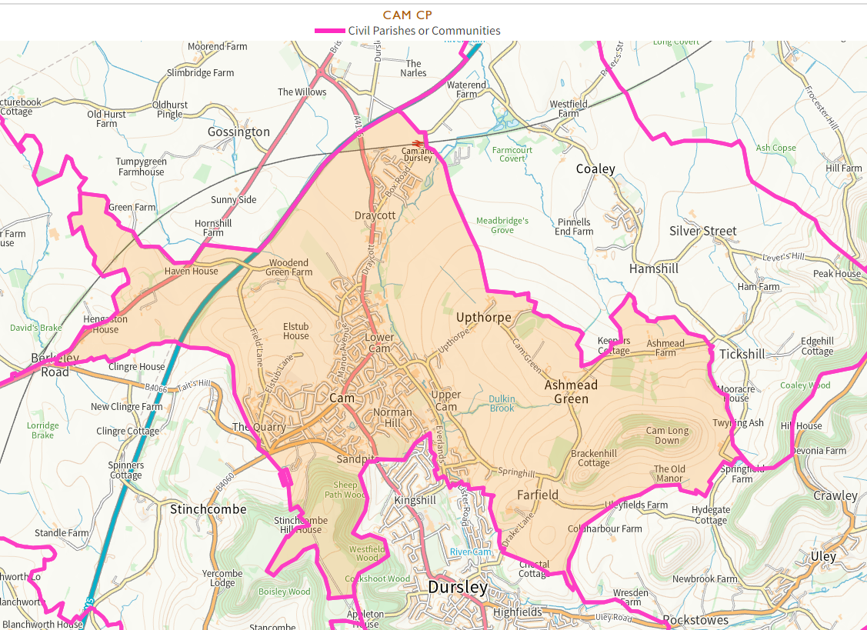
  - First stage consultation
    - Cam Parish Council made a detailed submission requesting a change to the parish warding arrangements to create an additional ward (North Ward) and increase the number of Councillors. Further submissions were made including one request to change the style of parish to ‘Town’, this change cannot be implemented by a CGR.
  - Draft recommendations
    - The Working Group used the Aston Business School guidelines to help evaluate the request for an additional Councillor. Cam parish was already at the maximum number of Councillors as per the electorate size and indicated by the Aston Business School guidelines. The Working Group did not feel as though they had received sufficient evidence to consider going beyond the current scale of representation and therefore did not wish to recommend an increase in the number of Councillors. The Working Group considered at length the proposals for an additional parish ward called ‘North Ward’, they agreed with the request in principle, however, decided that it would be premature to make any changes at the current time. The Working Group wanted to be able to listen to and understand the views of those residents who would be living within the proposed ward to ensure that any changes made reflected community identity. As much of the development in this area had not yet taken place the Working Group agreed that time should be allowed for a community to develop further so future residents could be part of the decision on the future of their parish.
    - The Working Group therefore recommended no changes but suggested that a future CGR could be carried out if required within the next five to seven years.
  - Second stage consultation
    - Two responses were received, the response from the clerk advised that the Parish Council were disappointed that no changes had been recommended but appreciated the opportunity to review this again in the future. A response was also received from a Parish Councillor which suggested that the Cam Parish boundary should also be altered to include the potential Wisloe development towards the motorway.

  - Final recommendations
    - The Working Group considered both responses received but felt that more evidence was needed to make any changes to the warding arrangements. Furthermore, to make any recommendations regarding the external parish boundary neighbouring parishes would need to be consulted with and therefore the change to any external parish boundaries which could not be completed within the timescale of this CGR. The Working Group believed that Cam could be considered as part of a CGR prior to the next scheduled local elections in May 2028.
    - FINAL RECOMMENDATIONS

    - It is RECOMMENDED that the following community governance and electoral arrangements be approved;-
a) A Community Governance Review for Cam parish is held before 2028.

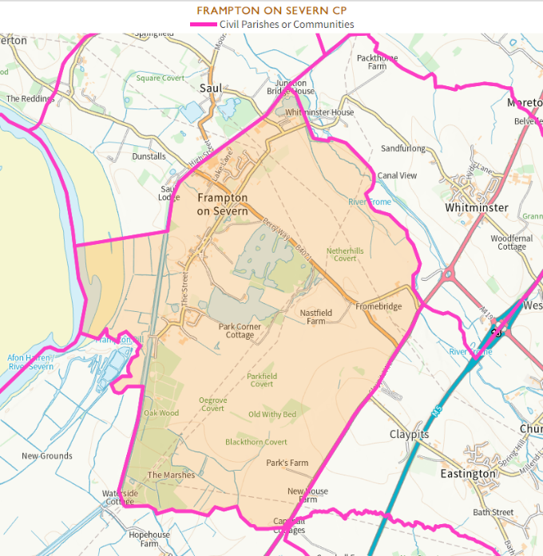
FRAMPTON-ON-SEVERN PARISH COUNCIL INCREASE IN COUNCILLORS
  - First stage consultation
7.1.1 Frampton-on-Severn Parish Council along with two parish councillors made a submission requesting an increase to number of Councillors by one due to the potential increase in the size of electorate from new developments and the workload of the active Parish Council. A submission was also received requesting a new parish ward in the Oatfield area due to expected development.
  - Draft recommendations
    - The Working Group were satisfied that an additional councillor would allow the parish to continue to provide good services and governance for their increasing electorate. The Parish Council had quickly filled vacancies in the past which highlighted a keen interest in parish matters for residents.
    - The Working Group were satisfied that an additional councillor would still be within the scale of representation.
    - The Working Group recommended no changes to the warding arrangements but suggested that a CGR could be carried out in the future once any developments near Oatfield Road had been established.
  - Second stage consultation
    - Frampton parish council supported the draft recommendations.
  - Final recommendations
    - The Working Group agreed that the proposed increase from nine to ten councillors would ensure that effective and convenient community governance continued. They also agreed that the Council should look to hold a CGR in the future once a community is established at the Oatfield site.
7.4.2 FINAL RECOMMENDATIONS

7.4.3 It is RECOMMENDED that the following community governance and electoral arrangements be approved;
- The number of Parish Councillors for Frampton-on-Severn Parish Council is increased to TEN.
- A Community Governance Review for Frampton-on-Severn Parish is considered in the future if the development at Oatfield becomes established.

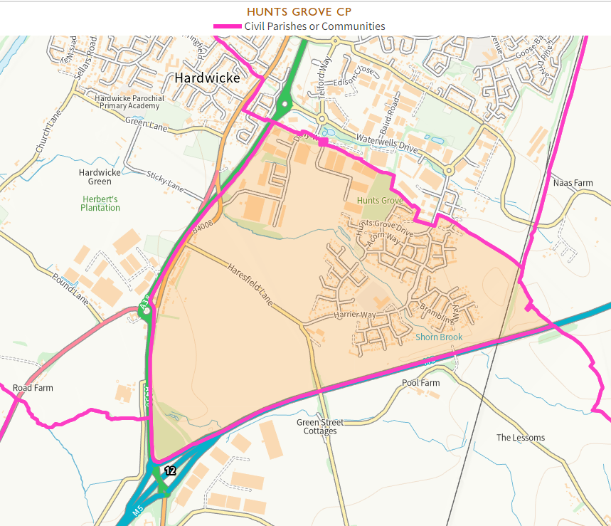
HUNTS GROVE PARISH COUNCIL INCREASE IN COUNCILLORS

  - First stage consultation
    - Hunts Grove Parish Council made a submission requesting an increase to the number of Councillors to eleven due to the size of electorate, the increasing workload of Councillors and the increasing number of services provided by the Parish Council. A large number of submissions in support of an increase in the number of Councillors were also received along with four requests for no changes. Two further submissions were received, one requesting the Council remains as it is and does not merge with another parish and one to group the parish.
  - Draft recommendations
    - The Working Group considered at length the submissions for Hunts Grove parish and took into account the large increase in electorate that had occurred due to the ongoing development in the area and the increase in services being provided by the Parish. The Parish Council had been formulated as a result of the last Community Governance Review in 2019 and due to the significant increase in electorate was now outside the recommended scale of representation.
    - The Working Group were satisfied that additional councillors were necessary to continue to provide effective and convenient governance, robust parish arrangements and allow the Parish Council to take on additional services, if and when required. They considered the size of the current Parish Council alongside parish councils of a similar size and nature and the Aston Business School guidelines. They recommended that an increase to nine parish councillors would be within the scale of representation, allow for good governance and help to ensure that the Parish Council remained quorate.
  - Second stage consultation
    - Hunts Grove parish council supported the draft recommendations however they requested that the number of Councillors would be considered again after 2 years due to the number of services the council expected to be managing in the future.
  - Final recommendations
    - The Working Group carefully considered the original recommendation and response to the consultation. A member of the Working Group who was also a member of the Parish Council provided further information and advised that the Parish Council was considering the option to take on further services from the management company over the next few years but that this was still in the early planning stages. Due to the large increase in councillor numbers already recommended, the Working Group didn’t feel that they had enough evidence to warrant recommending a larger increase at this stage. Due to the work involved in carrying out a CGR, they also did not want to commit the Council to carrying out a further CGR in 2 years time but agreed that contact should be made with the Parish Council when the Council next carries out a CGR so that the number of councillors could be considered again.
8.4.2 FINAL RECOMMENDATIONS

8.4.3 It is RECOMMENDED that the following community governance and electoral arrangements be approved;-
- The number of Parish Councillors for Hunts Grove is increased to NINE.

MINCHINHAMPTON AND BRIMSCOMBE PARISH COUNCIL FUTURE COMMUNITY GOVERNANCE REVIEW
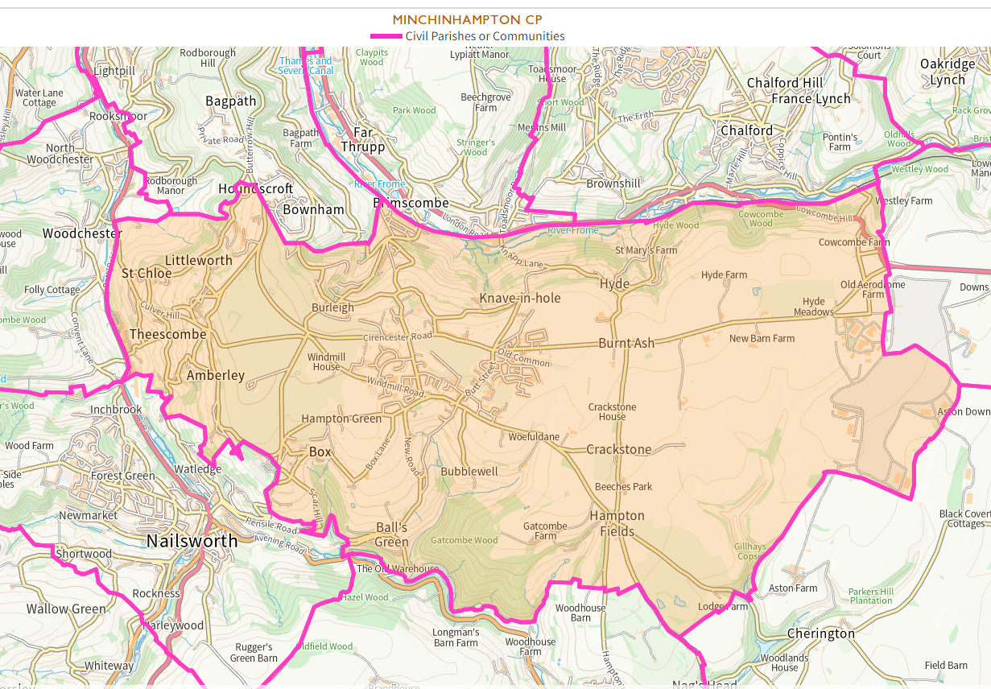
  - First stage consultation
    - Minchinhampton Parish Council had been included as part of the CGR due to a request from Nailsworth Town Council to consider its boundaries. Following Nailsworths withdrawal of their initial proposal, Minchinhampton Parish Council requested that no changes were made to the parish arrangements. Two further submissions were submitted by residents supporting no change. One submission was made requesting that some of the parish wards were made into their own parishes and the number of councillors be reduced. A submission was also made by Brimscombe and Thrupp Parish Council requesting an amendment with Minchinhampton (Brimscombe Ward) stating the neighbourhoods and new developments within the Brimscombe Port area relied on the services of Brimscombe and Thrupp Parish. A number of submissions from local residents in this area supported Brimscombe and Thrupp Parish Councils submission.
  - Draft recommendations
    - The Working Group felt conflicted when considering the proposal for a boundary change between Brimscombe and Thrupp and Minchinhampton Parish Councils. The Group were aware that a similar proposal had been put forward by Brimscombe and Thrupp Parish Council as part of the previous review held in 2019. At that time, it was not felt that satisfactory evidence had been submitted to justify this amendment. On this occasion, the council has received an indication of support of this proposal through the number of submissions from residents. However, the lack of consultation with Minchinhampton Parish Council and the fact that Brimscombe and Thrupp Parish was not included in the Terms of Reference meant that the Working Group did not feel that it was in a position to be able to make a recommendation as part of this Community Governance Review.
    - The Working Group felt that it would be more appropriate to review the boundary once the Wimberley Mills housing development had been completed to allow the residents of the development the opportunity to be involved in any consultation. The Working Group therefore recommended that the boundary form part of a future CGR after the elections in May 2024 and before the next scheduled elections due to be held in 2028.
  - Second stage consultation
    - No response was received from Minchinhampton Parish Council. One submission was received on behalf of Brimscombe and Thrupp Parish Council which supported the recommendation to hold a CGR before the local elections in 2028.

  - Final recommendations
    - The consultation response demonstrated Brimscombe and Thrupp Parish Councils acceptance that any changes to the boundary needed to be carried out with a consultation of both parish councils and residents of the area. The Working Group therefore decided not to amend their recommendation.
    - FINAL RECOMMENDATIONS

    - It is RECOMMENDED that the following community governance and electoral arrangements be approved;-
- A Community Governance Review for Minchinhampton Parish and Brimscombe and Thrupp Parish is held before 2028.

CREATION OF GREAT OLDBURY PARISH COUNCIL AND AMENDMENTS TO STONEHOUSE TOWN, EASTINGTON AND STANDISH PARISH
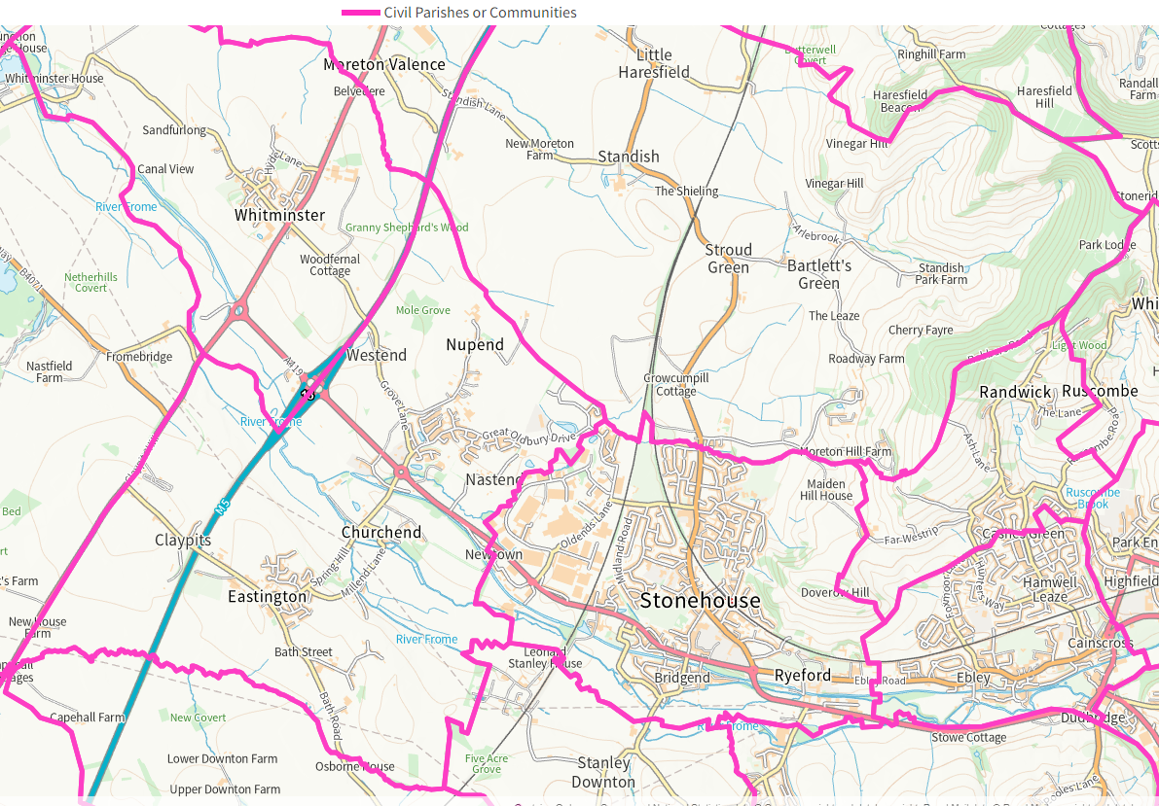
  - First stage consultation
    - Proposals were submitted by Eastington Parish Council, Keep Eastington Rural Community Group, Stonehouse Town Council and the Great Oldbury Community Group alongside a limited number of responses from local residents. The submissions from the Great Oldbury Community Group, Stonehouse Town Council and Keep Eastington Rural supported the creation of a new Parish for the Great Oldbury area. Eastington Parish Council put forward a number of options to be considered but advised that it would support the creation of a new parish if a direct consultation with residents was carried out.
  - Draft recommendations
    - The Working Group considered all options submitted and assessed in great detail whether Great Oldbury had an established community identity and whether it would benefit from the creation of a Parish Council.
    - The Working Group did not consider it appropriate for the whole of Great Oldbury to be transferred into Eastington or Stonehouse as the Great Oldbury Community Group had indicated their individuality and differences with their neighbouring parishes and had expressed a strong wish to form their own parish.
    - The Working Group believed that the submissions received from residents, community groups and neighbouring parishes demonstrated that the Great Oldbury community were strongly in support of establishing a new parish. This would give the electorate an independent voice and a structure for taking community action for its environment and facilities and independence in its own tax raising powers.
    - Section 93 of the Local Government and Public Involvement in Health Act 2007 identified three ‘tests’ which would need to apply when considering the creation of a new parish council.
- Community Identity – this was demonstrated in the detailed submissions received in support of a new parish which indicated a strong community identity, furthermore the creation of the new parish was supported by district ward councillors and neighbouring parishes.
- Effective and convenient local government – the current boundary results in Great Oldbury being split between three parishes, the creation of a new parish using clear boundaries would establish more effective and convenient local government. There are also parish councillors from the Great Oldbury area elected to Eastington Parish Council indicating a level of democratic engagement. However, Great Oldbury is currently split across 2 District Wards, the majority of the site sits within the Severn District Ward with a small portion towards the eastern boundary within Stonehouse District Ward. Alterations to the District Ward boundaries can only be made by the Local Government Boundary Commission for England.
- Adequate infrastructure or meeting points – Great Oldbury has begun to develop new infrastructure, there is currently a Primary School, playing fields and a small play area and there are plans for a community building.
    - No response was received from Standish Parish Council during the initial consultation. The Working Group considered the section of the Great Oldbury development site that was included within Standish Parish. As this had been identified as an employment site rather than residential properties, the Working Group felt that it should remain in Standish to avoid unnecessary alteration of the parish boundaries.
    - The recommendation for a new parish at Great Oldbury would result in boundaries that were not coterminous with the District Ward Boundaries. The recommendation therefore includes a request to the LGBCE to amend the boundaries of Severn and Stonehouse District Wards.
    - The Working Group also considered the scale of representation and proposed that the new parish would contain seven councillors.
    - Over time, significant development growth around Great Oldbury had changed the character of the area from that of the rest of the parish, effective governance would be improved for the area if it had its own Parish Council.
  - Second stage consultation
    - Eastington Parish Council, Stonehouse Town Council and Keep Eastington Rural responded to the consultation in support of the draft recommendations and the creation of the Great Oldbury Parish Council. Standish Parish Council submitted a response advising that the employment site within Standish Parish area was an integral part of the Great Oldbury development and therefore requested that it become part of the new parish along with the residential development.
    - 105 submissions were received from residents of Great Oldbury, 93 were in support of the creation of a new parish and 10 were against and 2 were in part support of the recommendations.
    - Those in support of the formation of a new parish for Great Oldbury noted that as a result of the significant development that had taken place on the Great Oldbury site its identity and interests were very different to the parish of Eastington and that a parish council solely for the area of Great Oldbury would be more relevant, would be able to better serve the interests of local residents and reflect the identity of the area more appropriately.
    - Comments opposed to the recommendation included that the area was suitably served by the existing parish council, that wider community ties to Eastington had been formed and there was no compelling reason to make a change.
  - Final recommendations
    - The Working Group note the responses from the small hamlets of Westend, Nastend and Nupend and agree that these remained of a distinct character compared to the more built up area of the nearby estate. Under the criteria it was therefore appropriate for these areas to remain within Eastington Parish.
    - Having considered the evidence, statutory criteria, guidance, other relevant information and consultation responses, the Working Group therefore agree that the Great Oldbury residents would be better served by their own parish. The proposal had passed the three ‘tests’ and the balance of evidence indicated that the community had sufficient grounds and support to progress Great Oldbury to formally becoming a parish council.
    - The creation of Great Oldbury Parish Council is the best way of recognising and developing further the community cohesion and identity within the area. It will offer strong and accountable local government and community leadership with the opportunity to take the lead locally on specific issues and represent the local community.
    - Accordingly, the Working Group recommend that the LGBCE be requested to amend the Severn and Stonehouse District Ward Boundaries to be coterminous in order for the small number of properties and land currently within Stonehouse Ward be transferred and absorbed into Severn District Ward.
    - One of the considerations of the LGBCE is the variances in the number of electors each councillor represents, with the aim to ensure there is equal representation across the Stroud district. The LGBCE has laid out criteria for initiating an electoral review which includes:
- more than 30% of a council’s wards/divisions having an electoral imbalance of more than 10% from the average ratio for that authority; and/or
- one or more wards/divisions with an electoral imbalance of more than 30%; and
- the imbalance is unlikely to be corrected by foreseeable changes to the electorate within a reasonable period.
    - The Severn District Ward is already showing a variance of greater than 30% and the transfer of additional electors from Stonehouse to Severn would increase the variance to approximately 37%. Because of this variance, it is possible that the LGBCE may reject the request to amend the ward boundaries and instead initiate a full District Ward review following the May 2024 Elections. In this scenario, the properties currently within Stonehouse district would still be recommended to form part of Great Oldbury parish but a new polling district would need to be created to ensure they remained part of Stonehouse district ward. Whilst this is not an ideal situation, it would be a temporary measure until the LGBCE had completed their review of the district wards to rebalance the current electoral variance.
    - Whilst producing the final recommendations we sought the views of the LGBCE so that we could determine the likelihood of them agreeing to alter the district ward boundaries with the current and projected variances. The LGBCE would not provide a determination until the final recommendations has been approved by Full Council. If Council is minded to agree the recommendations, we will contact the LGBCE as soon as possible to ensure they are given sufficient time to review the request.
    - The new parish boundaries will come into force at the May 2024 district and parish council elections and will apply to the electoral register published on the 1 December 2023.
  - FINAL RECOMMENDATIONS

    - It is RECOMMENDED that the following community governance and electoral arrangements be approved;-
- A new parish of Great Oldbury will be created and the parish should be called Great Oldbury Parish Council as shown on Map 1;
- The effective date for the new parish council will be the 1 April 2024, with elections for the parish council to take place in May 2024;
- Great Oldbury Parish Council should return SEVEN parish councillors;
- The parish should not be divided into wards;
- Changes are made to boundaries of the existing parishes of Eastington, Standish and Stonehouse as shown on Map 2;
- No changes are made to the councillor allocations for Standish Parish Council and Stonehouse Town Council; and
- The number of Parish Councillors for Eastington is decreased to NINE.
- A request to the LGBCE is made to amend the boundaries of Severn and Stonehouse District Wards to be coterminous with the new parish boundaries on the understanding that a District Ward review may need to take place as a result of the electoral variance in Severn Ward.

STONEHOUSE TOWN COUNCIL CREATION OF AND AMENDMENT TO WARD BOUNDARIES
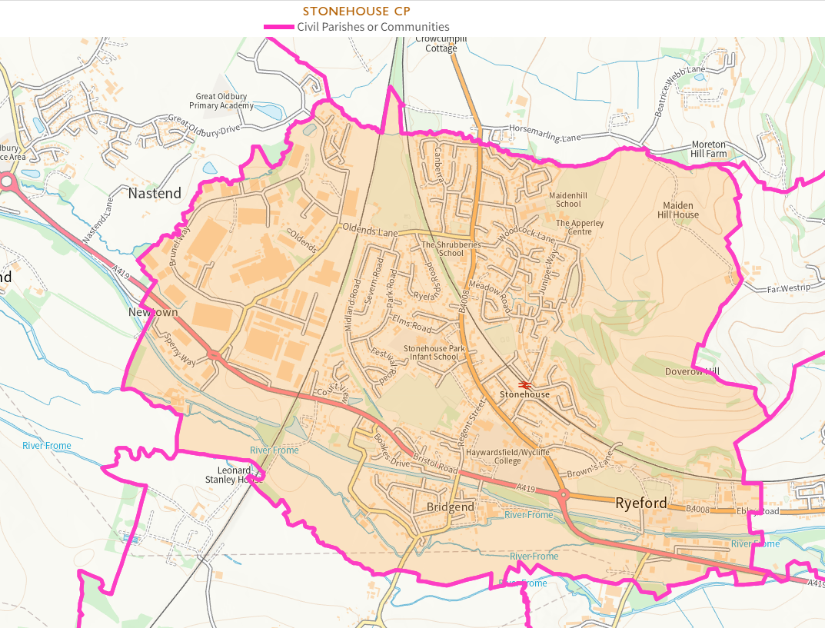
  - First stage consultation
    - Stonehouse Town Council made a submission requesting a change to the warding arrangements which they believed to not be suitable and the current warding arrangements should be removed. Two further submissions were received which requested a number of changes including transferring a number of areas to Stonehouse Town Council and reversing a change which was made during the last CGR held in 2019 to the boundary between Cainscross.
  - Draft recommendations
    - The Working Group considered the proposals made in the 2 submissions to the initial consultation, however, did not feel that enough evidence had been provided to justify recommending and changes to the boundaries for Stonehouse.
    - The Working Group considered in depth the warding arrangements for Stonehouse and felt that removing the warding arrangements entirely would not lead to more effective and convenient community governance. The Working Group instead proposed the creation of three wards similar to the arrangements that were in place prior to 2016 which would help to ensure equal representation across the town council.
    - The working group recommended that the number of Councillors for each ward was proportionately based on the number of electors within each ward:
- Stonehouse North Ward – 6 Councillors
- Stonehouse South Ward – 4 Councillors
- Stonehouse Central Ward – 4 Councillors
  - Second stage consultation
    - Stonehouse Town Council responded to confirm that the support the draft recommendations for the warding arrangements and the councillor allocation.
  - Final recommendations
    - The Working Group agreed that the proposed change to warding arrangements and councillor allocations would help to ensure equal representation and were necessary for effective and convenient local governance in the area.
  - FINAL RECOMMENDATIONS

    - It is RECOMMENDED that the following community governance and electoral arrangements be approved;-
- The warding arrangements of the Town of Stonehouse are redrawn to create three wards, North, Central and South Wards as shown on Map 3;
- The allocation of Councillors is redistributed across the wards with an allocation of SIX Councillors for North Ward, FOUR Councillors for South Ward and FOUR Councillors for Central Ward.

STANDISH PARISH COUNCIL FUTURE COMMUNITY GOVERNANCE REVIEW
  - First stage consultation
    - Standish Parish Council made a submission during the first stage of consultation but did not make any suggestions or recommendations for change. They identified that further development within the Parish may happen and a further CGR would be required to look at the governance arrangements if necessary.
  - Draft recommendations
    - The Working Group considered the Local Plan site PS19a, as outlined in Map 4, at great length but believed that it was important that future residents of the site of any new development should be consulted with before making any recommendations for change. It was therefore recommended that there was no change to the current arrangements at this time.
  - Second stage consultation
    - Standish Parish Council supported the draft recommendations.
  - Final recommendations
    - The Working Group agreed that no changes to governance arrangements were required at the current time however they reaffirmed the recommendation that should the site at PS19a be developed a further CGR would be required.
  - FINAL RECOMMENDATIONS

    - It is RECOMMENDED that the following community governance and electoral arrangements be approved;-
- A Community Governance Review for Standish Parish is considered in the future the development at site PS19a becomes established.

AREAS WHERE NO CHANGES HAVE BEEN RECOMMENDED
  - The Working Group considered the consultation responses received for Dursley Town Council, Nailsworth Town Council and Horsley Parish Council and agreed that there was a lack of evidence to support any changes.
  - Dursley Town Council had requested that the current arrangements were reviewed to ensure that they were still adequate, further submissions were received which were supportive of the current arrangements.
  - Nailsworth Town Council withdrew their initial request for a review of their boundaries with neighbouring parish and town councils, no further submissions were received that requested any changes to the current arrangements.
  - Horsley Parish Council were initially included in the review due to Nailsworth Town Councils request to review its boundaries, no requests were received for any alterations to its current governance arrangements.
  - Furthermore, a submission was received from Woodchester Parish Council during the second stage of consultation which requested a reduction in the number of Councillors from seven to six. The Parish Council advised that the existing councillors felt that the parish council performed better as a functioning body of six members. Further information was requested from Woodchester Parish Council to ensure the Working Group were able to make an informed final recommendation.
  - Although a reduction in the number of seats would be within the guidelines of Aston Business School, the Parish Council would be reducing the number of seats to a size typically held by a much smaller Parish Council with a considerably smaller electorate.
  - After consideration of the response provided and the guidelines used, the Working Group agreed that there was a lack of evidence to support a reduction in the number of Councillor seats on the Parish Council as it was an active Parish Council and historically had no issue filling vacant seats indicating a level of democratic engagement within the parish.

CONCLUSION AND NEXT STEPS
  - If Council chooses to accept the final recommendations of the Review, it will be necessary for the One Legal team in conjunction with the Corporate Policy and Governance Manager to prepare a Reorganisation Order and publish this together with the reasons for the changes, making maps available for public inspection. There are also various bodies that must be notified of the changes including:
- The Secretary of State for Levelling Up, Housing and Communities
- The Local Government Boundary Commission for England (LGBCE)
- The Office for National Statistics
- The Director General of Ordnance Survey
- Any other principal council whose area the order relates to (in this case, Gloucestershire County Council)
- The Audit Commission.
  - All residents whose property has been affected by a parish boundary change will be notified in writing.
  - If the consequential alterations are agreed by the LGBCE, the new parish boundaries will take effect on 1 April 2024, ahead of the next scheduled parish elections in May 2024 and will apply to the electoral register published on the 1 December 2023.

IMPLICATIONS
  - Financial Implications
There are no financial implications arising directly from this report. The creation of a new Parish does create obligations for the Council to support the new organisation but this is expected to be achieved through existing officer time.

Andrew Cummings, Strategic Director of Resources
Email: andrew.cummings@stroud.gov.uk

  - Legal Implications
The Local Government and Public Involvement in Health Act 2007 devolves the power to take decisions about the creation of parishes and their electoral arrangements to local government and local communities.

Principal Councils (which includes District Councils) have a responsibility to undertake Community Governance Reviews and can decide whether to give effect to recommendations made in those reviews save that any consequential recommendations for related alterations to the electoral areas require approval of, and implementation by, the LGBCE.

In accordance with the provisions of the 2007 Act, the Council has had regard to the Guidance on community governance reviews issued by the Secretary of State and the LGBCE when preparing the Recommendations in this report.

In relation to consequential changes to district ward boundaries, the Commission will want to see that specific consultation has been undertaken on ward boundaries as well as the Parish boundaries themselves. The Commission can only accept or reject all the requested related alterations. Accordingly, if there are changes to ward boundaries which are likely to have a significant impact on the electoral equality of the affected district wards, the Commission may not support these.

One Legal
Email: legalservices@onelegal.org.uk

  - Equality Implications
An EIA has been carried out by Officers in relation to the decision made in this report and can be found at Appendix D, due regard will be given to any implications identified in it.

  - Environmental Implications
There are no significant implications within this category.

