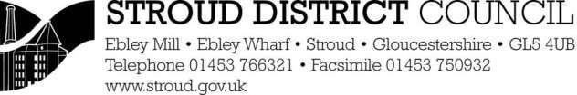


£564.00

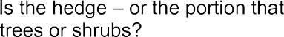







I have paid the fee of £564.00

